W10 - PRACTICE
Monster Slayer

 At the end of this practice, you should be able to…
- Use all concepts you have learned so far to create a complex project

 How to work?
- Download the start code from the Google classroom
- For each exercise you can either:
  - Run npm install
  - Or move an existing node_modules to the exercise folder (fastest option!)

How to submit?
- Create a repository on GitHub with the name of this practice:
Ex: C2-S1-PRACTICE
- Push your final code on this GitHub repository (if you are lost, follow this tutorial)
- Finally, submit on Google classroom your GitHub repository URL
Ex: https://github.com/thebest/ C2-S1-PRACTICE.git

 Are you lost?
You can read the following documentation to be ready for this practice:
https://www.w3schools.com/react/react_jsx.asp
https://www.w3schools.com/react/react_props.asp
https://www.gatsbyjs.com/docs/how-to/images-and-media/importing-assets-into-files/

Understand the game rules
Start with playing the game online, and understand its rules:
https://reactjs-game-practice.vercel.app/

In this game you need to fight against a monster:
- You can choose to attack (the monster will attack back)
- Or heal yourself (the monster will also attack back)
- Every 3 turns, you can use a special attack
- You can also kill yourself if you want 😊

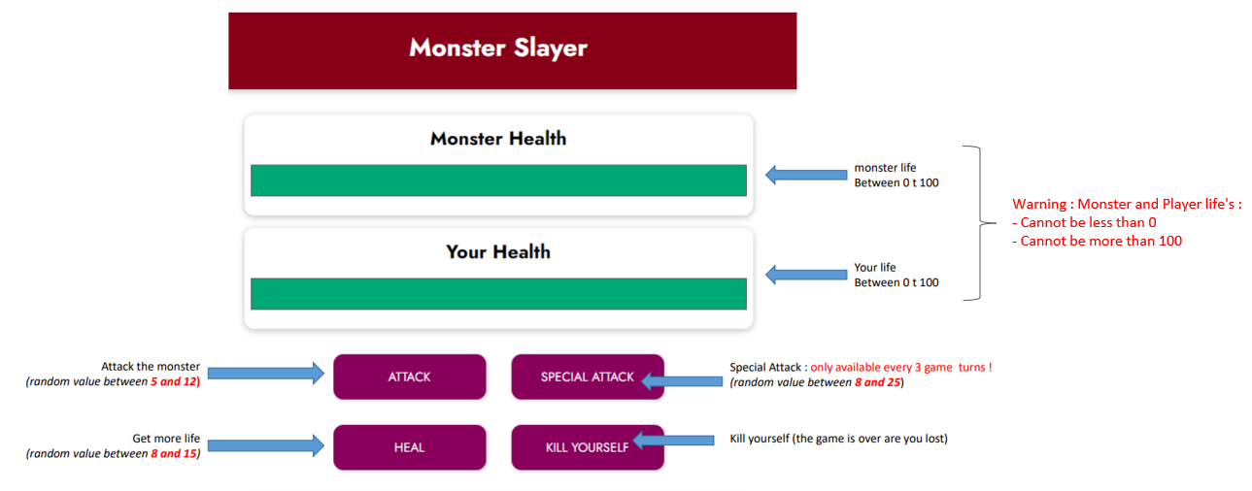

The game will also contain a dedicated component to display all actions:
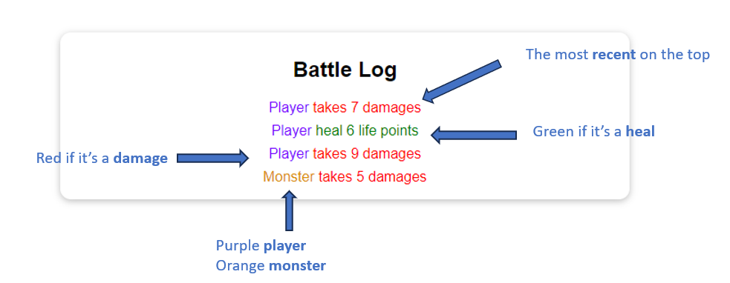

Finally, the game over component will display the result (you won, you lost, draw game).
- The player can also start a new game

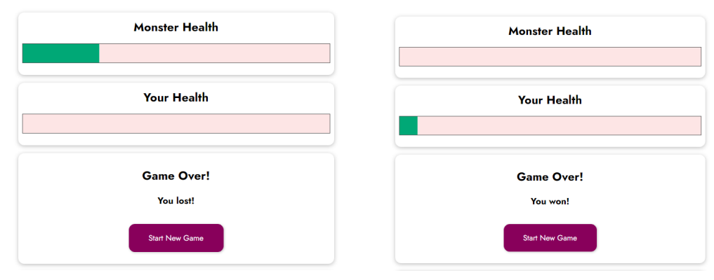

1. Vanilla HTML to React components

As start code we provide:
- A vanilla HTML CSS project, which serves as example to style and structure your HTML
- A start REACT JS project, that will contain your code

The goal of this first activity is only to move the HTML and CSS code from vanilla project to your new React JS components….

Q1 – First understand the vanilla HTML CSS project:
- Which CLASSES are used?
  - Classes used:
    - .healthbar
    - .healthbar__value
    - .container
    - .log—player
    - .log—monster
    - .log—damage
    - .log--heal
- Which ID are used?
  - ID used:
    - #controls
    - #log

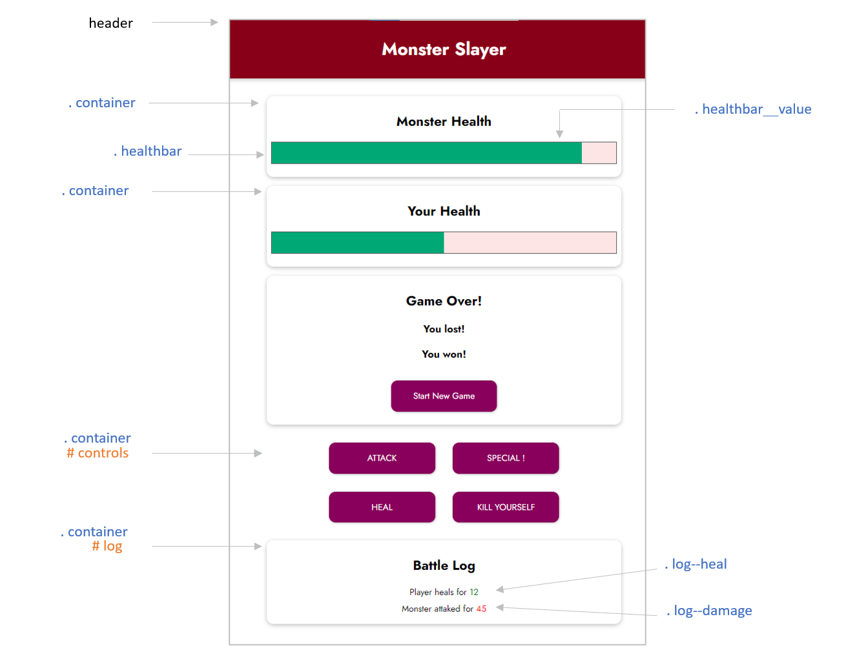

Q2 – Then, In your REACT JS project, create the components and move the HTML/CSS code

- Header: representing the game header

- Game: containing all game logic and game sub components
- Entity: representing the monster or player’s heath

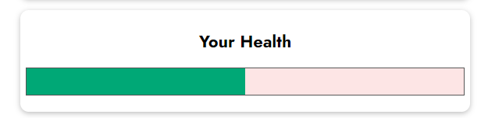

- Game Over: informing about the end of the game:
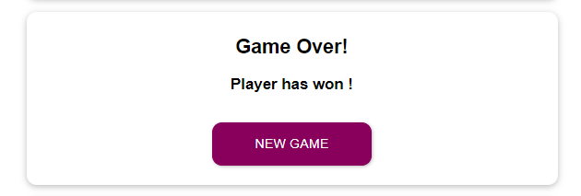

- Log: representing all the game actions
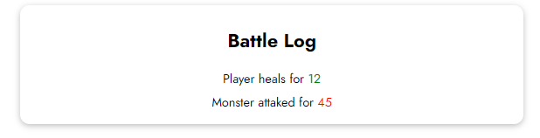

As a result, here is how your app components and its sub component could look like

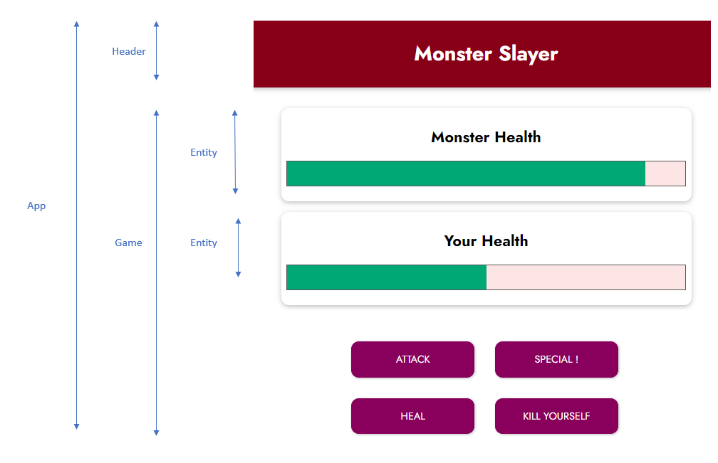

Q3 – Draw the component diagram (power point) to represent how your components communicate.
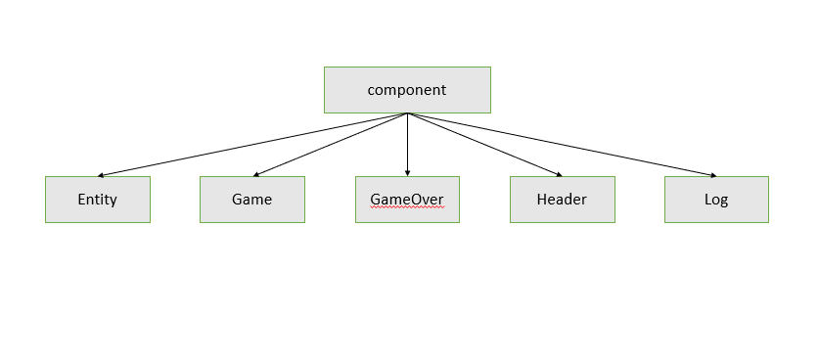

2. Entity component
The Entity component gets 2 parameters:
- The health percentage a number from 0 to 100
- The entity name: either Player or Monster

Q1 – Complete your code
- To display the health bar properly in the Entity component
- To create 2 entities (monster and player) in the Game component

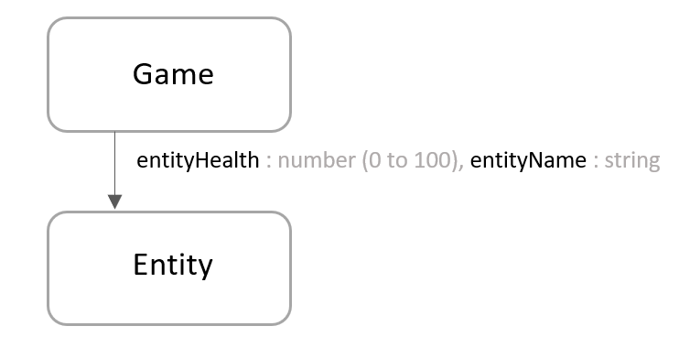

3. Game over component
The GameOver component gets 2 parameters:
- The title: the game over message to display in the <h3>
- The restartGame: a function reference to be called when user click on start new game.

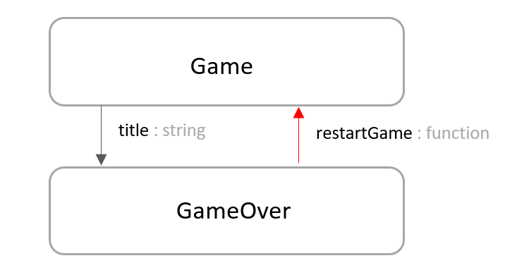

4. Log component
Each log message can be stored using the following data structure:
- isPlayer: whether its s the player or the monster
- isDammage: whether it’s a damage or a heal
- text: the text to display
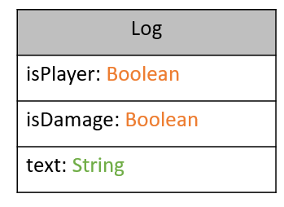

Note: we already have created some helper function in the Game component to create log messages.

The Logs component gets 1 parameter:
- The list of logs, following the above structure

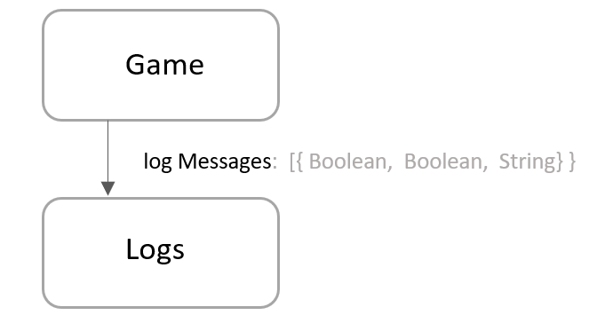

The Logs component shall display each log, following the color specification:

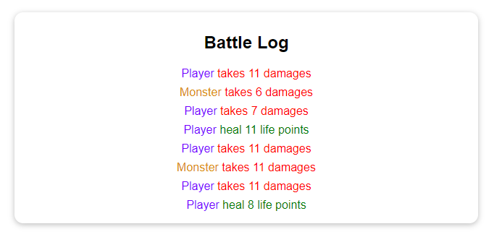

5. Game component
The Game component handles the game logic. It will be the main component of your project.

Q1 – Take time to list down the states and the computed values you will need to handle all your game features.

Note: Computed values are data that do not need a state, as they can be computed from other data (state, constant, variable.)

For example: how will you manage whether the game is over, who has won? Whether the special attack need to be displayed or not? How will you store the logs? Etc.

State | Type | Role
playerHealth | number | Store player HP
monsterHealth | number | Store monster HP
currentRound | Number | Track rounds
logs | array | Store all logs

Computed values | Type | Role
winner | string | Decide who wins
specialAvailable | boolean | Check if special attack is allowed

Q2 – Link your states ad computed value to your component’s attributes
- Visibility of the GameOver, the buttons
- The monster and player health bar (Entity component)
- The log component (call this component in Game component and throw prop that Log needs)
Link states to components
- Entity: uses playerHealth and monsterHEalth
- GameOver: shows only when winner is not null
- Buttons: hidden when game ends
- Log: receives logs array
Q3 – Handle actions related to each button, following the specifications. You need to create 4 functions to handle each button.
- To control these functions you need to have 1 more function that will return all the button above (you can copy the UI from vanilla html) when game is not over.

Note: we already have created a helper function in the Game component to generate a random value between a min and a max value.

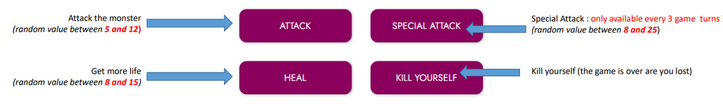

Q4 – Handle the end of the game

The GameOver component shall display when the game is over, and propose the player to start a new game. (in here you need to have a function that contain some conditions, like when will it return GameOver component? and text message as well, then call this function into return of Game component)

Note: What do you need to update to start a new game?
Game ends when:
- playerHealth <= 0
- monsterHealth <= 0
Cases:
- both 0 -> Draw
- player 0 -> Monster wins
- monster 0 -> player Wins
To restart:
- reset playerHeath = 100
- reset monsterHealth = 100
- reset logs
- reset round
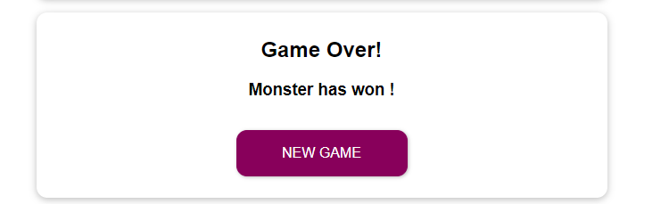

6. Test and deploy on Vercel

Q1 – You game should handle every situation

For instance, did you think about those difference cases?
- What s happen in case of draw game?
- Can player or monster have more than 100% life?
- Can player or monster have less than 0% life?

Q2 – Before deploying, clean up your code

- Each function needs comments
- Remove useless code, useless variables…

Q3 – Push your code on GitHub and deploy on Vercel (search on internet how to deploy)

